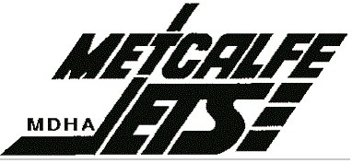 NAME & PHOTO PERMISSION FORM

Player’s Name (Printed): _________________________ Team for 2019-20 Season: _________________

The Metcalfe & District Hockey Association would like to provide the name and photo of all league players on our website. In addition, the MDHA may from time to time take photographs, video of games, practices or events to use on the website and within the local media promoting our hockey teams.

The MDHA is committed to preserving your child’s privacy and security. We understand that some parents (families) may not wish to have their pictures and/or names used for any of these purposes.

Please fill out the form whether you consent or not by circling the appropriate boxes. If you are consenting to the use of your child’s name and/or photo, you are hereby releasing the MDHA from any liability resulting from or connected to the publication of the player’s name and/or photo.

YES | NO | My child’s first and last name may be electronically displayed and published on our website/social media.
YES | NO | My child’s first and last name may be electronically displayed and published on our website/ social media with pictures.
YES | NO | Individual photographs of my child may be electronically displayed and published on the website/social media and within other league printed media.
YES | NO | Group photographs (such as team pictures) of my child may be electronically displayed and published on the website/social media and in other league media.

Note: It is the Parent/Guardian’s responsibility to notify the Team Manager in writing of the status of this consent changes.

Parent/Guardian Name(s): _________________________________________________________________

Parent/Guardian Signature(s): _________________________________________________________________

Date: __________________________________________________________________

